ds-tcrm-es03.tcsbank.ru ip: 10.219.44.8 https://netbox.tcsbank.ru/dcim/devices/5016/ iLO: 10.219.104.148
ds-tcrm-es04.tcsbank.ru ip: 10.219.44.9 https://netbox.tcsbank.ru/dcim/devices/5014/ iLO: 10.219.104.149
ds-tcrm-es05.tcsbank.ru ip:10.219.44.10 https://netbox.tcsbank.ru/dcim/devices/5015/ iLO: 10.219.104.150

m1-tcrm-es03.tcsbank.ru ip:10.219.43.8 10.214.43.8 https://netbox.tcsbank.ru/dcim/devices/4866/ iLO: 10.219.102.151
m1-tcrm-es04.tcsbank.ru ip:10.219.43.9 10.214.43.9 https://netbox.tcsbank.ru/dcim/devices/4867/ iLO: 10.219.102.154

https://jira.tcsbank.ru/browse/ITP-2347

https://sd.tcsbank.ru/0/Nui/ViewModule.aspx#SectionModuleV2/CaseSection/CasePage/edit/1f18eb98-154b-4fde-a857-c04396868617
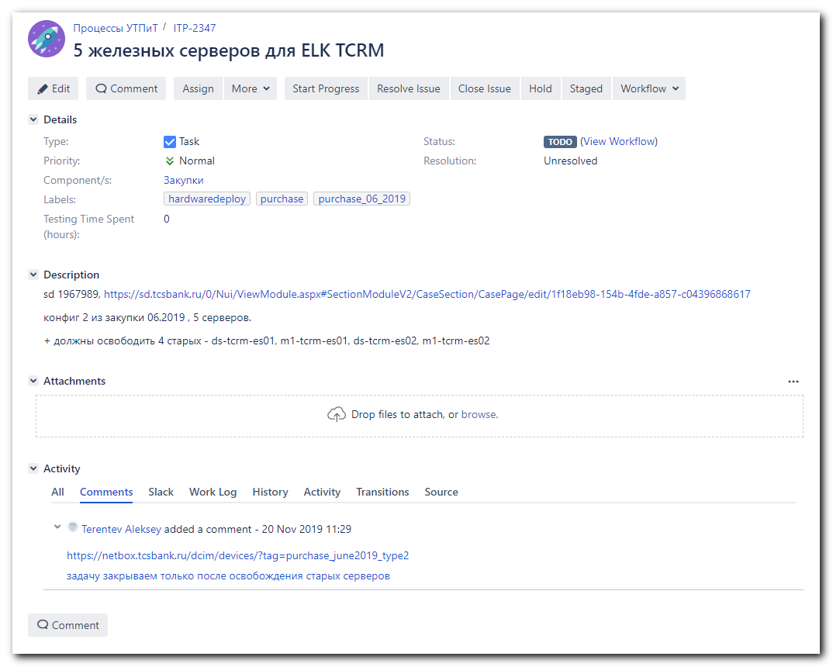

https://netbox.tcsbank.ru/dcim/devices/?tag=purchase_june2019_type2
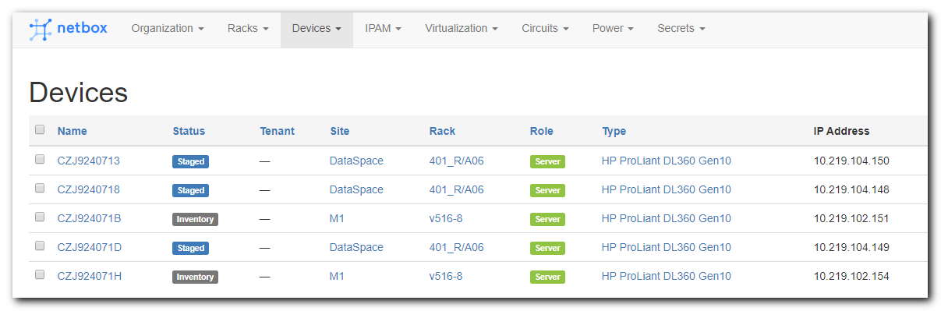

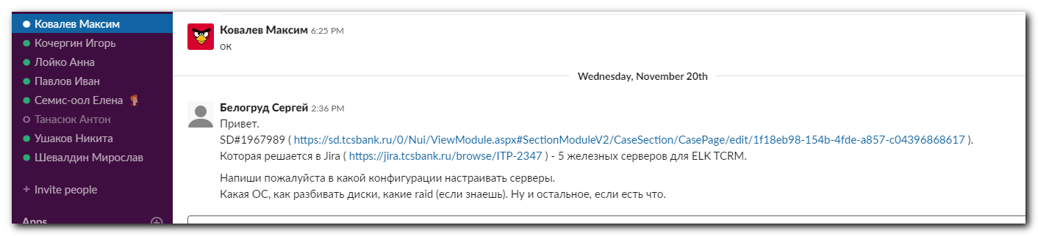
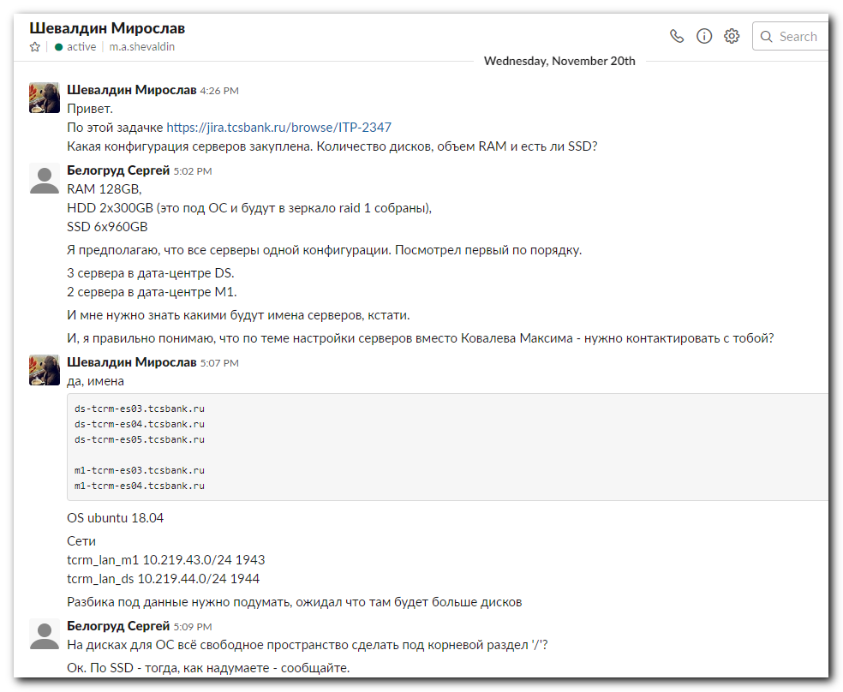
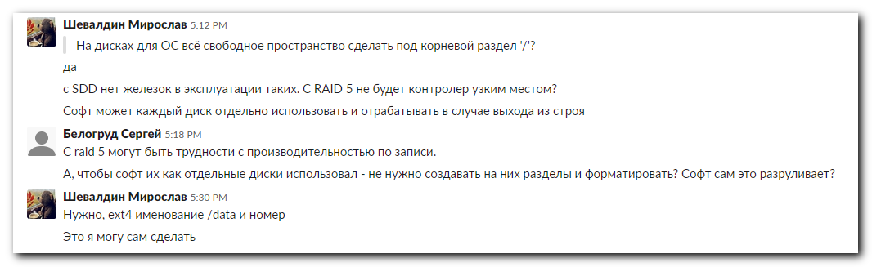

#
# Here is an example of exist host.
#
[root@ds-tcrm-es02 ~]# ip a | grep -w inet
inet 127.0.0.1/8 scope host lo
inet 10.219.44.7/24 brd 10.219.44.255 scope global team0
[root@ds-tcrm-es02 ~]#

[root@ds-tcrm-es02 ~]# cat /etc/redhat-release
CentOS Linux release 7.6.1810 (Core)
[root@ds-tcrm-es02 ~]# cat /etc/sysconfig/network-scripts/ifcfg-team0
DEVICE=team0
DEVICETYPE=team
NAME=team0
ONBOOT=yes
TEAM_CONFIG='{"runner": {"name": "activebackup"}, "link_watch": {"name": "ethtool"}}'
IPADDR=10.219.44.7
GATEWAY=10.219.44.254
PREFIX=24
DNS1=10.219.50.4
DNS2=10.219.50.5
DOMAIN=tcsbank.ru

[root@ds-tcrm-es02 ~]#

[root@ds-tcrm-es02 ~]# cat /etc/sysconfig/network-scripts/ifcfg-ens3f0
TYPE=Ethernet
BOOTPROTO=none
NAME=ens3f0
UUID=c0251a12-c5c3-4be6-a9bc-473adc33a62e
DEVICE=ens3f0
ONBOOT=yes
TEAM_MASTER=team0
DEVICETYPE=teamport
[root@ds-tcrm-es02 ~]# cat /etc/sysconfig/network-scripts/ifcfg-ens3f1
TYPE=Ethernet
BOOTPROTO=none
NAME=ens3f1
UUID=63bbded4-c29c-4127-9556-0ff2cb5e89a7
DEVICE=ens3f1
ONBOOT=yes
TEAM_MASTER=team0
DEVICETYPE=teamport
[root@ds-tcrm-es02 ~]#

[root@m1-tcrm-es02 ~]# ip a | grep -w inet
inet 127.0.0.1/8 scope host lo
inet 10.219.43.7/24 brd 10.219.43.255 scope global team0
[root@m1-tcrm-es02 ~]# cat /etc/redhat-release
CentOS Linux release 7.6.1810 (Core)
[root@m1-tcrm-es02 ~]# cat /etc/sysconfig/network-scripts/ifcfg-team0
DEVICE=team0
DEVICETYPE=team
NAME=team0
ONBOOT=yes
TEAM_CONFIG='{"runner": {"name": "activebackup"}, "link_watch": {"name": "ethtool"}}'
IPADDR=10.219.43.7
GATEWAY=10.219.43.254
PREFIX=24
DNS1=10.219.50.4
DNS2=10.219.50.5
DOMAIN=tcsbank.ru
ONBOOT=yes

[root@m1-tcrm-es02 ~]#

[root@m1-tcrm-es02 ~]# cat /etc/sysconfig/network-scripts/ifcfg-ens5f0
TYPE=Ethernet
BOOTPROTO=none
NAME=ens5f0
UUID=eb29ef5f-ac37-465c-8df6-2068d97419d5
DEVICE=ens5f0
ONBOOT=yes
TEAM_MASTER=team0
DEVICETYPE=teamport
[root@m1-tcrm-es02 ~]# cat /etc/sysconfig/network-scripts/ifcfg-ens5f1
TYPE=Ethernet
BOOTPROTO=none
NAME=ens5f1
UUID=42cec9fd-4a0b-4c23-88d7-6f7dc4e5171e
DEVICE=ens5f1
ONBOOT=yes
TEAM_MASTER=team0
DEVICETYPE=teamport
[root@m1-tcrm-es02 ~]#

From: Belogrud Sergey Vladimirovich <s.belogrud@tinkoff.ru>
Sent: Monday, November 25, 2019 4:07 PM
To: helpdesk_in <helpdesk_in@tinkoff.ru>
Cc: net-admins <net-admins@tinkoff.ru>
Subject: Настройка портов коммутаторов для серверов ds-tcrm-es03,04,05 и m1-tcrm-es03,04

Добрый день.

Задача на net-admins.

Требуется настройка портов коммутаторов для серверов:
ds-tcrm-es03.tcsbank.ru ip: 10.219.44.8 https://netbox.tcsbank.ru/dcim/devices/5016/ iLO: 10.219.104.148
ds-tcrm-es04.tcsbank.ru ip: 10.219.44.9 https://netbox.tcsbank.ru/dcim/devices/5014/ iLO: 10.219.104.149
ds-tcrm-es05.tcsbank.ru ip:10.219.44.10 https://netbox.tcsbank.ru/dcim/devices/5015/ iLO: 10.219.104.150

m1-tcrm-es03.tcsbank.ru ip:10.219.43.8 https://netbox.tcsbank.ru/dcim/devices/4866/ iLO: 10.219.102.151
m1-tcrm-es04.tcsbank.ru ip:10.219.43.9 https://netbox.tcsbank.ru/dcim/devices/4867/ iLO: 10.219.102.154

Настроить возможность использования на серверах в DS - vlan 1944 (10.219.44.0/24) - порт коммутатора в режиме Access.
Настроить возможность использования на серверах в M1 - vlan 1943 (10.219.43.0/24) - порт коммутатора в режиме Access.

Аналогично тому, как это уже сделано для сервера ds-tcrm-es02 или m1-tcrm-es02.

Оригинал исходной задачи: https://jira.tcsbank.ru/browse/ITP-2347 , SD#1967989.

Для серверов планируется использовать ip-адреса: 10.219.44.8, 10.219.44.9, 10.219.44.10, 10.219.43.8, 10.219.43.9.
Пожалуйста подтвердите, что эти адреса можно использовать для этих серверов. Или сообщите какие ip-адреса взять.

С уважением,

Сергей Белогруд
Старший системный администратор

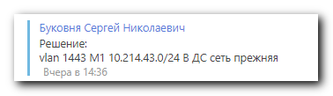

#
# By default after Ubuntu 18.04 was installed, network config was follow:
#
root@ds-tcrm-es03:~# cat ~/work/20191126-1645/01-netcfg.yaml
# This file describes the network interfaces available on your system
# For more information, see netplan(5).
network:
version: 2
renderer: networkd
ethernets:
eno5:
addresses: [ 10.219.44.8/24 ]
gateway4: 10.219.44.254
nameservers:
search: [ tcsbank.ru ]
addresses:
root@ds-tcrm-es03:~#

#
# After Bukovnya properly configured commutators and their ports, follow configuration starts working.
#
user@ds-tcrm-es03:~$ sudo -i
[sudo] password for user:
root@ds-tcrm-es03:~#
root@ds-tcrm-es03:~# cat /etc/netplan/01-netcfg.yaml
# This file describes the network interfaces available on your system
# For more information, see netplan(5).
network:
version: 2
renderer: networkd
ethernets:
eno5:
dhcp4: no
eno6:
dhcp4: no
bonds:
bond0:
dhcp4: no
dhcp6: false
interfaces: [eno5, eno6]
parameters:
mode: 802.3ad
mii-monitor-interval: 100
lacp-rate: fast
addresses: [ 10.219.44.8/24 ]
gateway4: 10.219.44.254
nameservers:
search: [ tcsbank.ru ]
addresses: [10.219.50.4, 10.219.50.5]

root@ds-tcrm-es03:~#

root@ds-prod-tbru-ts-db-1:~# echo 'APT::Get::AllowUnauthenticated "true";' > /etc/apt/apt.conf.d/99to-install-from-http

root@ds-prod-tbru-ts-db-1:~# egrep -v -e "^#|^$" /etc/apt/sources.list
deb http://archive.ubuntu.com/ubuntu bionic main restricted
deb http://archive.ubuntu.com/ubuntu bionic-updates main restricted
deb http://archive.ubuntu.com/ubuntu bionic universe
deb http://archive.ubuntu.com/ubuntu bionic-updates universe
deb http://archive.ubuntu.com/ubuntu bionic multiverse
deb http://archive.ubuntu.com/ubuntu bionic-updates multiverse
deb http://archive.ubuntu.com/ubuntu bionic-backports main restricted universe multiverse
deb http://archive.ubuntu.com/ubuntu bionic-security main restricted
deb http://archive.ubuntu.com/ubuntu bionic-security universe
deb http://archive.ubuntu.com/ubuntu bionic-security multiverse
root@ds-prod-tbru-ts-db-1:~#

root@ds-prod-tbru-ts-db-1:~# vim /etc/apt/sources.list
:%s/http:\/\/archive.ubuntu.com/http:\/\/repo-linux.tcsbank.ru\/repository/gc
# or
:%s/http:\/\/us.archive.ubuntu.com/http:\/\/repo-linux.tcsbank.ru\/repository/gc
:%s/http:\/\/security.ubuntu.com/http:\/\/repo-linux.tcsbank.ru\/repository/gc

root@ds-prod-tbru-ts-db-1:~#

root@m1-prod-tbru-ts-tb-1:~# apt-get update
Get:1 http://repo-linux.tcsbank.ru/repository/ubuntu bionic InRelease [242 kB]
Get:2 http://repo-linux.tcsbank.ru/repository/ubuntu bionic-updates InRelease [88.7 kB]
...
Get:35 http://repo-linux.tcsbank.ru/puppetlabs/apt bionic/puppet5 amd64 Packages [28.3 kB]
Fetched 19.9 MB in 7s (2,959 kB/s)
Reading package lists... Done
root@m1-prod-tbru-ts-tb-1:~#

root@ds-prod-tbru-ts-db-1:~# cat /etc/apt/sources.list
deb http://repo-linux.tcsbank.ru/repository/ubuntu bionic main restricted
deb http://repo-linux.tcsbank.ru/repository/ubuntu bionic-updates main restricted
deb http://repo-linux.tcsbank.ru/repository/ubuntu bionic universe
deb http://repo-linux.tcsbank.ru/repository/ubuntu bionic-updates universe
deb http://repo-linux.tcsbank.ru/repository/ubuntu bionic multiverse
deb http://repo-linux.tcsbank.ru/repository/ubuntu bionic-updates multiverse
deb http://repo-linux.tcsbank.ru/repository/ubuntu bionic-backports main restricted universe multiverse
deb http://repo-linux.tcsbank.ru/repository/ubuntu bionic-security main restricted
deb http://repo-linux.tcsbank.ru/repository/ubuntu bionic-security universe
deb http://repo-linux.tcsbank.ru/repository/ubuntu bionic-security multiverse
root@ds-prod-tbru-ts-db-1:~#

[support@centos puppet]$ ansible-playbook 20180808-1512.install.puppet-agent.yaml -i list_of_hosts --become --extra-vars "ansible_user=user ansible_password=$(pass common/linux-other3) ansible_sudo_pass=$(pass common/linux-other3) ansible_ssh_common_args='-oStrictHostKeyChecking=no -oPubkeyAuthentication=no'"

PLAY [all] ************************************************************************************************************************************************************************************************

TASK [Gathering Facts] ************************************************************************************************************************************************************************************
ok: [10.214.3.112]

TASK [Add Puppetlabs Repo v5 (rpm) for RHEL] **************************************************************************************************************************************************************
skipping: [10.214.3.112]

TASK [Add Puppetlabs Repo v5 (deb)] ***********************************************************************************************************************************************************************
ok: [10.214.3.112]

TASK [Add Puppetlabs Repo key (deb)] **********************************************************************************************************************************************************************
ok: [10.214.3.112]

TASK [Install puppet-agent via apt module on Ubuntu with option -y] ***************************************************************************************************************************************
[WARNING]: Could not find aptitude. Using apt-get instead

changed: [10.214.3.112]

TASK [Install new puppet] *********************************************************************************************************************************************************************************
skipping: [10.214.3.112]

TASK [Set puppet server in config] ************************************************************************************************************************************************************************
changed: [10.214.3.112]

TASK [Enable agent (for ubuntu)] **************************************************************************************************************************************************************************
fatal: [10.214.3.112]: FAILED! => {"changed": true, "cmd": "puppet agent --enable", "delta": "0:00:00.001942", "end": "2019-11-27 16:06:21.988932", "msg": "non-zero return code", "rc": 127, "start": "2019-11-27 16:06:21.986990", "stderr": "/bin/sh: 1: puppet: not found", "stderr_lines": ["/bin/sh: 1: puppet: not found"], "stdout": "", "stdout_lines": []}
...ignoring

TASK [First run puppet] ***********************************************************************************************************************************************************************************
fatal: [10.214.3.112]: FAILED! => {"changed": false, "disabled": false, "error": true, "msg": "puppet did not run", "rc": 1, "stderr": "", "stderr_lines": [], "stdout": "Info: Creating a new SSL key for m1-prod-tbru-ts-tb-1.tcsbank.ru\nInfo: Caching certificate for ca\nInfo: csr_attributes file loading from /etc/puppetlabs/puppet/csr_attributes.yaml\nInfo: Creating a new SSL certificate request for m1-prod-tbru-ts-tb-1.tcsbank.ru\nInfo: Certificate Request fingerprint (SHA256): 3E:7B:F1:C2:D2:78:C8:6C:C4:59:4D:0C:14:4B:E2:35:19:34:FE:54:A6:CF:14:36:69:17:31:BE:ED:CD:42:6D\nInfo: Caching certificate for ca\nExiting; no certificate found and waitforcert is disabled\n", "stdout_lines": ["Info: Creating a new SSL key for m1-prod-tbru-ts-tb-1.tcsbank.ru", "Info: Caching certificate for ca", "Info: csr_attributes file loading from /etc/puppetlabs/puppet/csr_attributes.yaml", "Info: Creating a new SSL certificate request for m1-prod-tbru-ts-tb-1.tcsbank.ru", "Info: Certificate Request fingerprint (SHA256): 3E:7B:F1:C2:D2:78:C8:6C:C4:59:4D:0C:14:4B:E2:35:19:34:FE:54:A6:CF:14:36:69:17:31:BE:ED:CD:42:6D", "Info: Caching certificate for ca", "Exiting; no certificate found and waitforcert is disabled"]}
...ignoring

PLAY RECAP ************************************************************************************************************************************************************************************************
10.214.3.112 : ok=7 changed=3 unreachable=0 failed=0 skipped=2 rescued=0 ignored=2

[support@centos puppet]$

[root@vm-puppetmaster02p ~]# puppet cert sign m1-prod-tbru-ts-tb-1.tcsbank.ru
Signing Certificate Request for:
"m1-prod-tbru-ts-tb-1.tcsbank.ru" (SHA256) 3E:7B:F1:C2:D2:78:C8:6C:C4:59:4D:0C:14:4B:E2:35:19:34:FE:54:A6:CF:14:36:69:17:31:BE:ED:CD:42:6D
Notice: Signed certificate request for m1-prod-tbru-ts-tb-1.tcsbank.ru
Notice: Removing file Puppet::SSL::CertificateRequest m1-prod-tbru-ts-tb-1.tcsbank.ru at '/etc/puppetlabs/puppet/ssl/ca/requests/m1-prod-tbru-ts-tb-1.tcsbank.ru.pem'
[root@vm-puppetmaster02p ~]#

#
# Relogin under bsv.
#
root@m1-prod-tbru-ts-tb-1:~# deluser --remove-home user
Looking for files to backup/remove ...
Removing files ...
Removing user `user' ...
Warning: group `user' has no more members.
userdel: user user is currently used by process 2812
/usr/sbin/deluser: `/usr/sbin/userdel user' returned error code 8. Exiting.
root@m1-prod-tbru-ts-tb-1:~#

#
# On Ubuntu 18.04.
# To get availability to use ifup and ifdown commands - need to install package “ifupdown”.
#
root@m1-prod-tbru-ts-db-1:~# apt-get install ifupdown
Reading package lists... Done
Building dependency tree
Reading state information... Done
Suggested packages:
ppp rdnssd
The following NEW packages will be installed:
ifupdown
0 upgraded, 1 newly installed, 0 to remove and 50 not upgraded.
Need to get 55.9 kB of archives.
After this operation, 227 kB of additional disk space will be used.
Get:1 http://repo-linux.tcsbank.ru/repository/ubuntu bionic-updates/main amd64 ifupdown amd64 0.8.17ubuntu1.1 [55.9 kB]
Fetched 55.9 kB in 1s (66.5 kB/s)
Selecting previously unselected package ifupdown.
(Reading database ... 112635 files and directories currently installed.)
Preparing to unpack .../ifupdown_0.8.17ubuntu1.1_amd64.deb ...
Unpacking ifupdown (0.8.17ubuntu1.1) ...
Setting up ifupdown (0.8.17ubuntu1.1) ...
Created symlink /etc/systemd/system/multi-user.target.wants/networking.service → /lib/systemd/system/networking.service.
Created symlink /etc/systemd/system/network-online.target.wants/networking.service → /lib/systemd/system/networking.service.
Processing triggers for ureadahead (0.100.0-21) ...
Processing triggers for systemd (237-3ubuntu10.29) ...
Processing triggers for man-db (2.8.3-2ubuntu0.1) ...
root@m1-prod-tbru-ts-db-1:~#

root@m1-prod-tbru-ts-db-1:~# ifdown
ifdown: no interface(s) specified
ifdown: Use --help for help
root@m1-prod-tbru-ts-db-1:~# ifdown --help
Usage: ifdown <options> <ifaces...>

Options:
-h, --help this help
-V, --version copyright and version information
-a, --all process all interfaces marked "auto"
--allow CLASS ignore non-"allow-CLASS" interfaces
-i, --interfaces FILE use FILE for interface definitions
--state-dir DIR use DIR to store state information
-X, --exclude PATTERN exclude interfaces from the list of
interfaces to operate on by a PATTERN
-n, --no-act print out what would happen, but don't do it
(note that this option doesn't disable mappings)
-v, --verbose print out what would happen before doing it
-o OPTION=VALUE set OPTION to VALUE as though it were in
/etc/network/interfaces
--no-mappings don't run any mappings
--no-scripts don't run any hook scripts
--no-loopback don't act specially on the loopback device
--force force de/configuration
--ignore-errors ignore errors
root@m1-prod-tbru-ts-db-1:~# ifdown eno6:
Unknown interface eno6:
root@m1-prod-tbru-ts-db-1:~#

root@m1-prod-tbru-ts-db-1:~# apt-get install lldpad
Reading package lists... Done
Building dependency tree
Reading state information... Done
The following additional packages will be installed:
libconfig9
The following NEW packages will be installed:
libconfig9 lldpad
0 upgraded, 2 newly installed, 0 to remove and 50 not upgraded.
Need to get 260 kB of archives.
After this operation, 778 kB of additional disk space will be used.
Do you want to continue? [Y/n] Y
Get:1 http://repo-linux.tcsbank.ru/repository/ubuntu bionic/universe amd64 libconfig9 amd64 1.5-0.4 [22.1 kB]
Get:2 http://repo-linux.tcsbank.ru/repository/ubuntu bionic/universe amd64 lldpad amd64 1.0.1+git20150824.036e314-2 [238 kB]
Fetched 260 kB in 4s (64.9 kB/s)
Selecting previously unselected package libconfig9:amd64.
(Reading database ... 112600 files and directories currently installed.)
Preparing to unpack .../libconfig9_1.5-0.4_amd64.deb ...
Unpacking libconfig9:amd64 (1.5-0.4) ...
Selecting previously unselected package lldpad.
Preparing to unpack .../lldpad_1.0.1+git20150824.036e314-2_amd64.deb ...
Unpacking lldpad (1.0.1+git20150824.036e314-2) ...
Processing triggers for ureadahead (0.100.0-21) ...
ureadahead will be reprofiled on next reboot
Setting up libconfig9:amd64 (1.5-0.4) ...
Processing triggers for libc-bin (2.27-3ubuntu1) ...
Processing triggers for systemd (237-3ubuntu10.29) ...
Processing triggers for man-db (2.8.3-2ubuntu0.1) ...
Setting up lldpad (1.0.1+git20150824.036e314-2) ...
Created symlink /etc/systemd/system/multi-user.target.wants/lldpad.service → /lib/systemd/system/lldpad.service.
Created symlink /etc/systemd/system/sockets.target.wants/lldpad.socket → /lib/systemd/system/lldpad.socket.
Processing triggers for libc-bin (2.27-3ubuntu1) ...
Processing triggers for systemd (237-3ubuntu10.29) ...
Processing triggers for ureadahead (0.100.0-21) ...
root@m1-prod-tbru-ts-db-1:~#

#
# https://vm-gitlab01.tcsbank.ru/Ansible/tcs_lldpad
# At this moment this shit doesn’t work for Ubuntu 18.04.
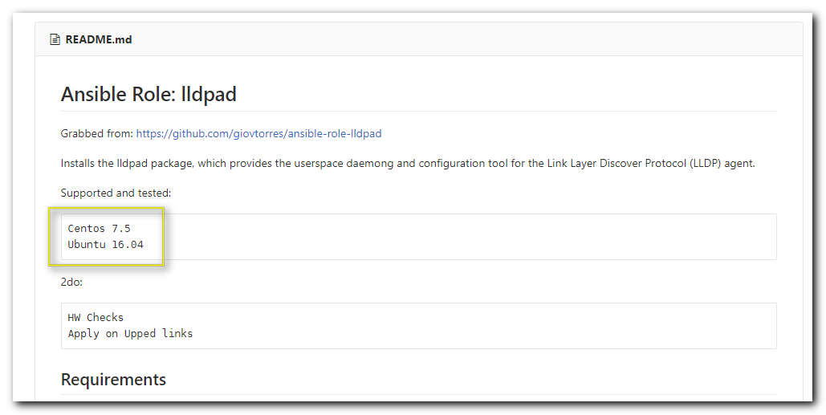

[support@centos tcs_lldpad]$ pwd
/home/support/work/20191202-1440.tcs_lldpad/tcs_lldpad
[support@centos tcs_lldpad]$

[support@centos tcs_lldpad]$ pwd
/home/support/work/20191202-1440.tcs_lldpad/tcs_lldpad
[support@centos tcs_lldpad]$ cat 20191202.lldp.playbook.yml
- hosts: all
serial: 30%

tasks:
- name: Apply lldp role
import_role:
name: tcs_lldpad
[support@centos tcs_lldpad]$
[support@centos tcs_lldpad]$ cat playbook.yml
---
- hosts: all
tasks:
- name: Install iproute
yum:
name: iproute
when: ansible_os_family == "RedHat"

- hosts: all
vars:
lldpad_active_interfaces: true
#lldpad_selected_interfaces:
# - eth0
roles:
- ansible-role-lldpad
[support@centos tcs_lldpad]$

#
# And this playbook doesn’t has role…
#
[support@centos tcs_lldpad]$ ansible-playbook 20191202.lldp.playbook.yml -i list_of_hosts --become --extra-vars "ansible_user=bsv ansible_password=$(pass common/linux) ansible_sudo_pass=$(pass common/linux) ansible_ssh_common_args='-oStrictHostKeyChecking=no -oPubkeyAuthentication=no'"
ERROR! the role 'tcs_lldpad' was not found in /home/support/work/20191202-1440.tcs_lldpad/tcs_lldpad/roles:/home/support/.ansible/roles:/usr/share/ansible/roles:/etc/ansible/roles:/home/support/work/20191202-1440.tcs_lldpad/tcs_lldpad

The error appears to be in '/home/support/work/20191202-1440.tcs_lldpad/tcs_lldpad/20191202.lldp.playbook.yml': line 7, column 15, but may
be elsewhere in the file depending on the exact syntax problem.

The offending line appears to be:

import_role:
name: tcs_lldpad
^ here

[support@centos tcs_lldpad]$

#
# Here I try to test bonding.
# And ifenslave doesn’t help in this at all.
#

root@m1-prod-tbru-ts-db-1:~# apt-get install ifenslave
Reading package lists... Done
Building dependency tree
Reading state information... Done
The following NEW packages will be installed:
ifenslave
0 upgraded, 1 newly installed, 0 to remove and 50 not upgraded.
Need to get 13.3 kB of archives.
After this operation, 49.2 kB of additional disk space will be used.
Get:1 http://repo-linux.tcsbank.ru/repository/ubuntu bionic/main amd64 ifenslave all 2.9ubuntu1 [13.3 kB]
Fetched 13.3 kB in 1s (22.4 kB/s)
Selecting previously unselected package ifenslave.
(Reading database ... 112672 files and directories currently installed.)
Preparing to unpack .../ifenslave_2.9ubuntu1_all.deb ...
Unpacking ifenslave (2.9ubuntu1) ...
Processing triggers for man-db (2.8.3-2ubuntu0.1) ...
Setting up ifenslave (2.9ubuntu1) ...
root@m1-prod-tbru-ts-db-1:~#

root@m1-prod-tbru-ts-db-1:~# ip link set dev eno6 down
root@m1-prod-tbru-ts-db-1:~# Connection reset by 10.214.3.112 port 22

[s.belogrud@TCS4357]# stty: standard input: Input/output error

[s.belogrud@TCS4357]# ssh bsv@m1-prod-tbru-ts-db-1.tcsbank.ru
Welcome to Ubuntu 18.04.3 LTS (GNU/Linux 4.15.0-70-generic x86_64)

* Documentation: https://help.ubuntu.com
* Management: https://landscape.canonical.com
* Support: https://ubuntu.com/advantage

System information as of Mon Dec 2 13:03:32 UTC 2019

System load: 0.07 Memory usage: 0% Processes: 778
Usage of /: 16.2% of 63.96GB Swap usage: 0% Users logged in: 1

* Canonical Livepatch is available for installation.
- Reduce system reboots and improve kernel security. Activate at:
https://ubuntu.com/livepatch

50 packages can be updated.
0 updates are security updates.

Failed to connect to https://changelogs.ubuntu.com/meta-release-lts. Check your Internet connection or proxy settings

Last login: Mon Dec 2 12:39:26 2019 from 172.16.28.74
bsv@m1-prod-tbru-ts-db-1:~$ sudo -i
[sudo] password for bsv:
root@m1-prod-tbru-ts-db-1:~# ifenslave -a
1: lo: <LOOPBACK,UP,LOWER_UP> mtu 65536 qdisc noqueue state UNKNOWN mode DEFAULT group default qlen 1000
link/loopback 00:00:00:00:00:00 brd 00:00:00:00:00:00
2: eno1: <BROADCAST,MULTICAST> mtu 1500 qdisc noop state DOWN mode DEFAULT group default qlen 1000
link/ether 80:30:e0:2e:5d:14 brd ff:ff:ff:ff:ff:ff
3: eno2: <BROADCAST,MULTICAST> mtu 1500 qdisc noop state DOWN mode DEFAULT group default qlen 1000
link/ether 80:30:e0:2e:5d:15 brd ff:ff:ff:ff:ff:ff
4: eno3: <BROADCAST,MULTICAST> mtu 1500 qdisc noop state DOWN mode DEFAULT group default qlen 1000
link/ether 80:30:e0:2e:5d:16 brd ff:ff:ff:ff:ff:ff
5: eno4: <BROADCAST,MULTICAST> mtu 1500 qdisc noop state DOWN mode DEFAULT group default qlen 1000
link/ether 80:30:e0:2e:5d:17 brd ff:ff:ff:ff:ff:ff
6: eno5: <BROADCAST,MULTICAST,SLAVE,UP,LOWER_UP> mtu 1500 qdisc mq master bond0 state UP mode DEFAULT group default qlen 1000
link/ether 8e:ea:79:62:3d:ce brd ff:ff:ff:ff:ff:ff
7: eno6: <BROADCAST,MULTICAST,SLAVE> mtu 1500 qdisc mq master bond0 state DOWN mode DEFAULT group default qlen 1000
link/ether 8e:ea:79:62:3d:ce brd ff:ff:ff:ff:ff:ff
8: bond0: <BROADCAST,MULTICAST,MASTER,UP,LOWER_UP> mtu 1500 qdisc noqueue state UP mode DEFAULT group default qlen 1000
link/ether 8e:ea:79:62:3d:ce brd ff:ff:ff:ff:ff:ff
9: bond0.1403@bond0: <BROADCAST,MULTICAST,UP,LOWER_UP> mtu 1500 qdisc noqueue state UP mode DEFAULT group default qlen 1000
link/ether 8e:ea:79:62:3d:ce brd ff:ff:ff:ff:ff:ff
root@m1-prod-tbru-ts-db-1:~#

